**Final Paper**

**World Domination**

**Nilendra Chaudhary Marni**

**Link to game drive:** https://drive.google.com/drive/folders/1yicr9wKZwdg6XROFp0WFVTJ6RBsj2HZ6?usp=sharing

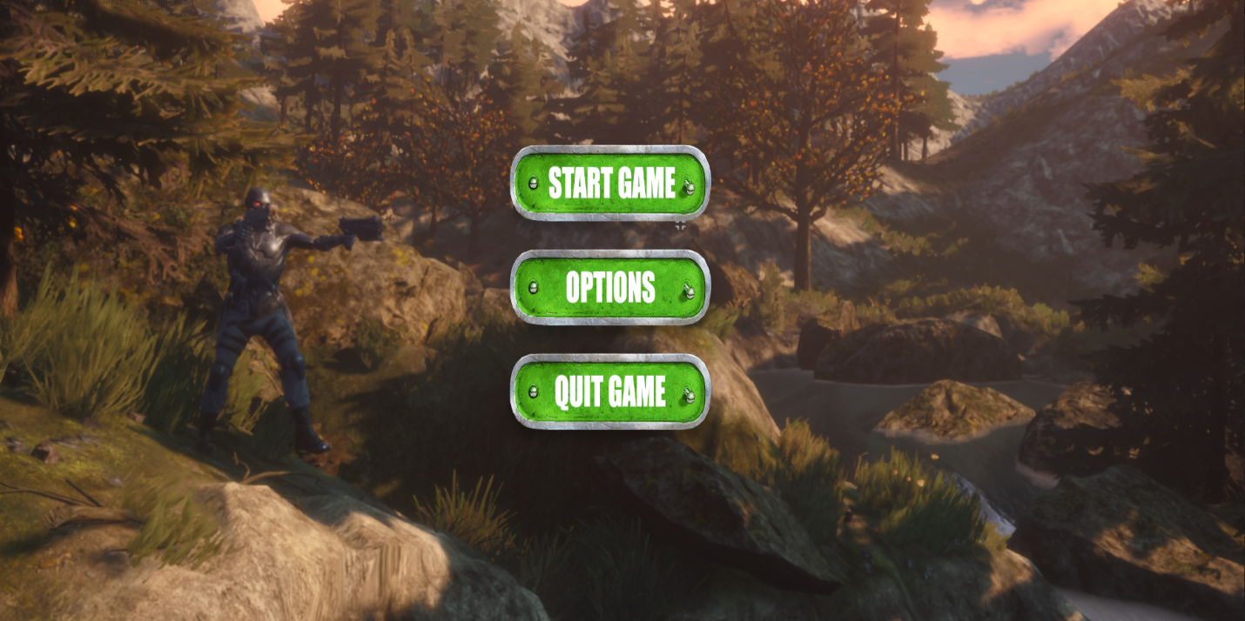

1. **What you are most proud of your game?**

This being a solo project, I am proud that I could complete all the core functionality of the game, and also a map with beautiful textures. I am also proud of implementing an Advanced AI using EQS which will hide whenever it sees us, which will further down the road be used to implemented as a sort of easter egg system, which these days is rarely or never been seen in a classic FPS.

**Some of the challenges encountered:**

**a)Hit registration using projectile:**

The shots fired by using a classic muzzle and projectile lead to the shots being very inaccurate discomforting the player, to counter this, There is a line tracing system implemented via the blueprints

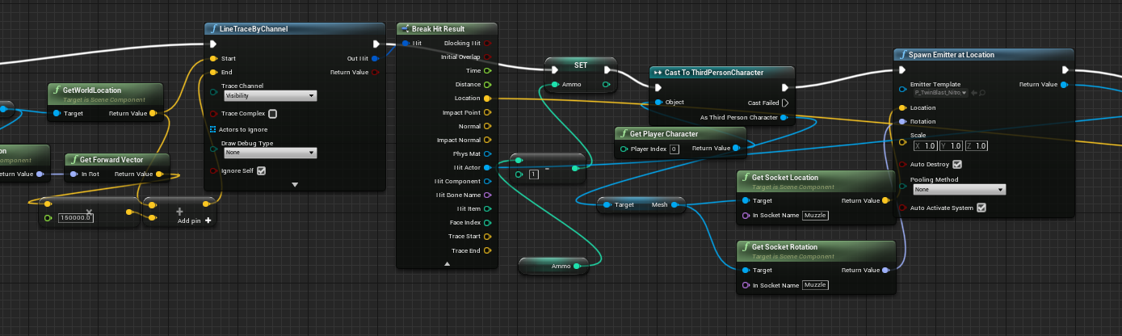

This system also emits a spark whenever it makes contact with the enemy at the hit location.

**b)Character Building:**

The character model was imported from the paragon package, but the animation and control was implemented by me, by importing the character model into my Third Person Model, Including movement, health and armor system, which is intuitive, where the armor is regeneratable and takes damage before the health.

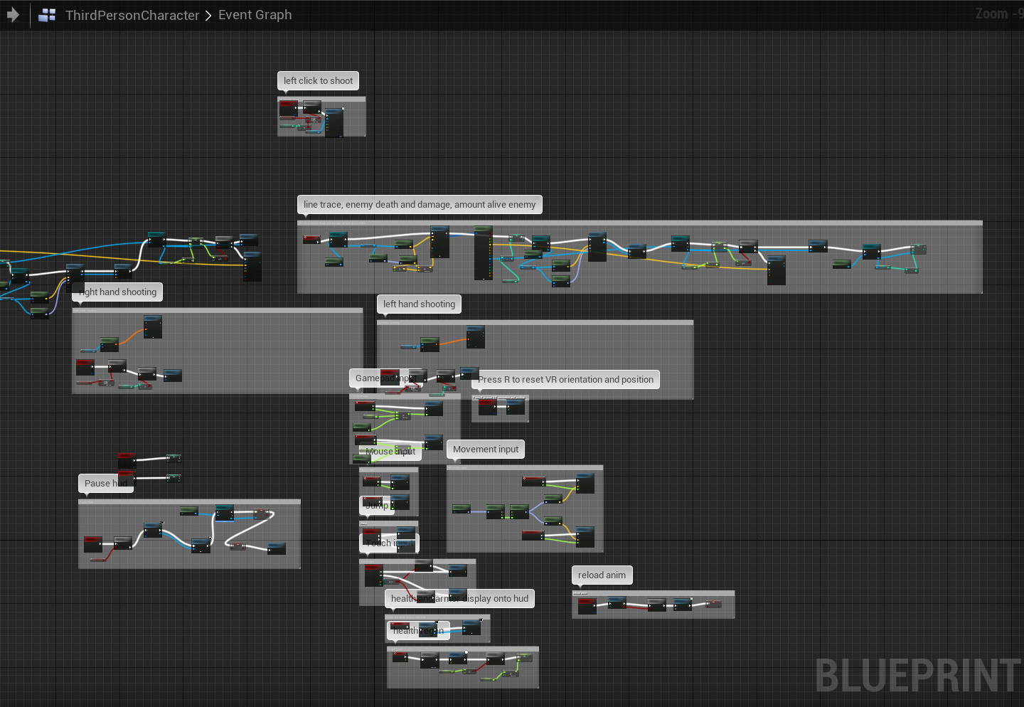

Using blend space built into Unreal Engine 4 and using it to animate player and enemy AI

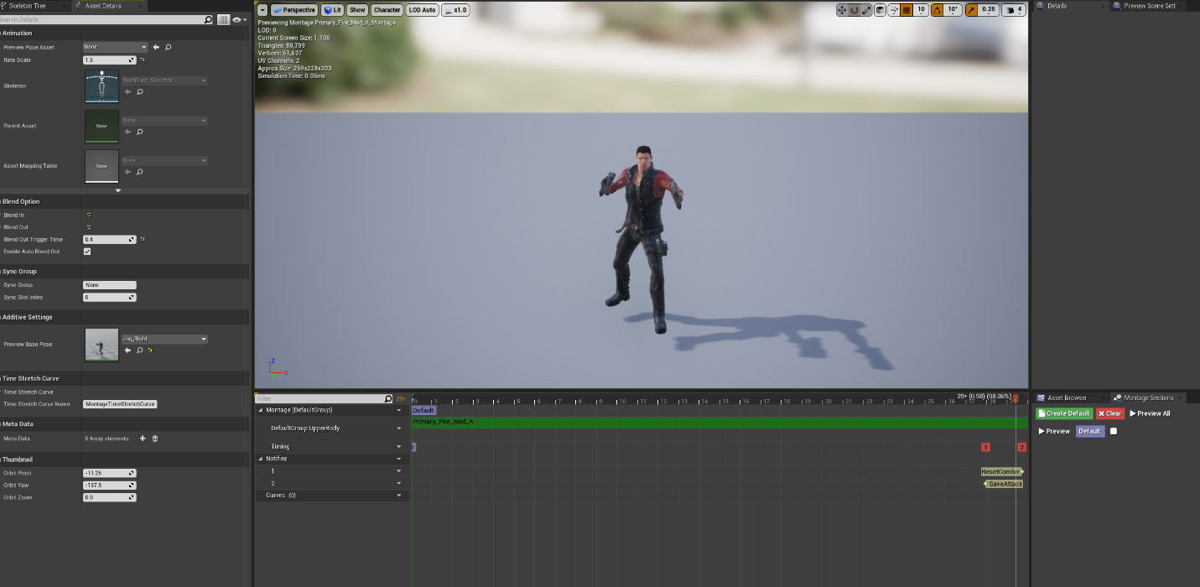

Enemy blend for attack and walk at the pelvis bone

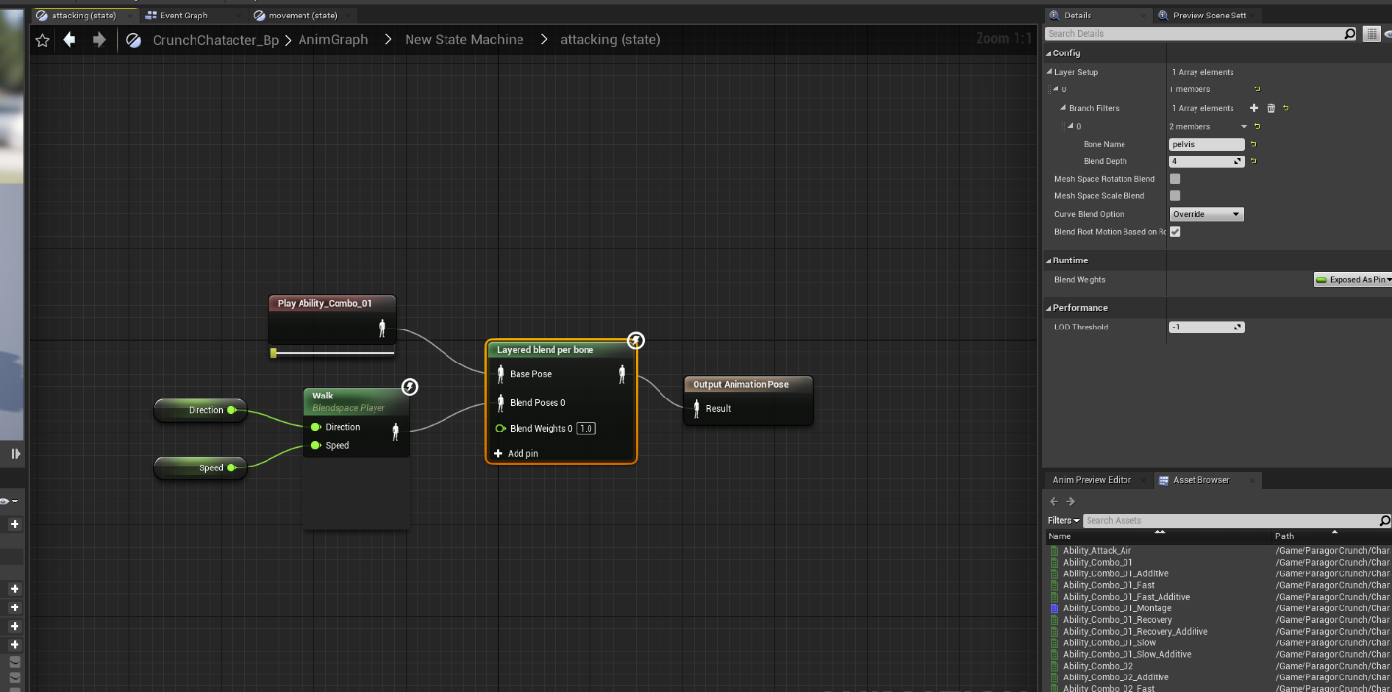

1. **What changes you made to your original game design for technical reasons and why?**

**Jetpack:** This was not implemented into the game due to the navmesh not being able to scale up to heights which are off the ground, the enemy AI would basically stand still breaking the game combat system.

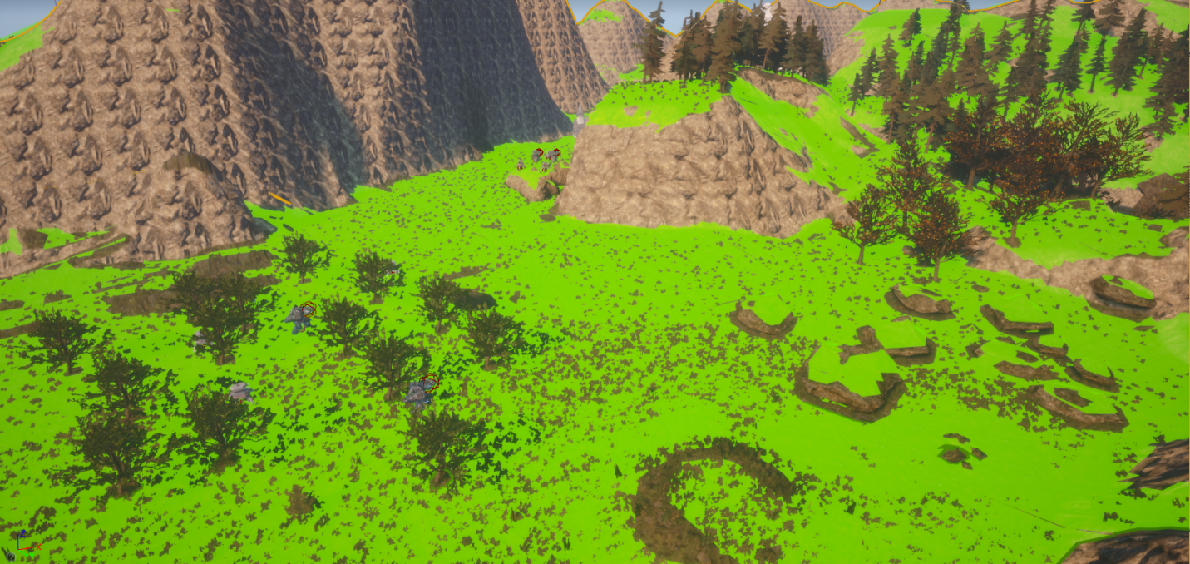

**Rocket Launcher:** Due to time constraints and AOE damage not being applied to the enemy, the ion blaster was removed and the mech was later turned into a melee bot with the same HP as the rest of the bots.

1. **What changes you made to your original game design for playability reasons and why?**

Applying the EQS to AI for combat proved to be too efficient as it was hard for the player to get around it, and slowing down the bot gave the player the ability to snipe it from long range, so the Advanced AI has now been implemented as a form of a easter egg bot which will hide from the player whenever it sees it, and eventually it will have added functionality such that whenever the player finds it, there will be something rewarding for the player in it.

1. **What did you learn from your play-testers?**

I let a few of my friends who like fps games try my game, they were very pleased with the graphical aspect of the game. One of them suggested that with the game including hunting for hiding bots, it would be a better idea to include a pause menu, as not all people like to do everything in one sitting, another one of my friends commented that the bots with EQS were hard to counter, even with debris they would keep swarming him(He doesn’t have a very good aim), and the last of the suggestions I received was there was a lack of direction in the map, as per their advice, I added multiple small buildings to reflect camps, providing proper points of reference.

1. **What changes did you make to your game as a result of the play-testing?**
2. I added a UI as per my friends instructions for pause menu, which further redirects us to the main menu.

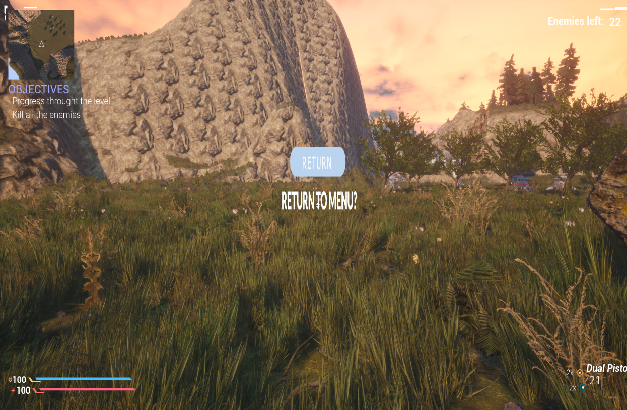

b) As the bots were hard to beat for an average player, I instead implemented an Advanced AI which hides from player using EQS, with further plans of making it an easter egg.

c) There was a lack of direction, so I used the brush to create a type of valley and small buildings to indicate camps, as such making it easier for the player to traverse the game objectives.

1. **What would you do next if u had more time?**

Next I would try to get the enemies to follow the player while the player was in air, as to add jetpack functionality without any problem, also to the EQS AI, I would make it an easter egg and add a rewarding component once found, if not found, when I implement further levels I will make it such that these hidden bots become a formidable AI, so the player at the least tries to find it.

I would add a further boss and add the missile launcher capability to counter the boss, providing the missile launcher as an easter egg drop, else the battle will be really hard.

I would also make the map fair bit larger and assign bot hierarchy, such that we have a mini boss in the stage somewhere and smaller bots to support it.

1. **What would you do differently next time?**

If I had to do something different next time, I would start by implementing an AI which would follow the player outside of the nav-mesh bound, also I would change the way I worked with the third person character, it gave me a significant amount of pain to get things to work with the existing animation, in the end I had to give up and make an entire animation of my own anyway for the majority of the functions.

Finally, my project size it too large to upload it to the canvas, as such I have uploaded it to a google drive, the link has been provided at the beginning of the document, and I will also include the link in the canvas submission.